University of Central Missouri

Department of Computer Science & Cybersecurity

CS5710 Machine Learning

Fall 2025

Home Assignment 4.

Student name: Beesa Vaishnavi(700772902)

Submission Requirements:
- Once finished your assignment push your source code to your repo (GitHub) and explain the work through the ReadMe file properly. Make sure you add your student info in the ReadMe file.
- Comment your code appropriately IMPORTANT.
- Any submission after provided deadline is considered as a late submission.

Part A: Calculation

Q1. Find the cluster using the Average and MIN technique. Use Euclidean distance to build the complete distance matrix, updated the distance matrix to the final step and draw the dendrogram for each.
 | X | Y
P1 | 0.4 | 0.5
P2 | 0.2 | 0.3
P3 | 0.1 | 0.08
P4 | 0.21 | 0.12
P5 | 0.6 | 0.16
P6 | 0.33 | 0.28
P7 | 0.11 | 0.15
Solution:
Euclidean Distance:
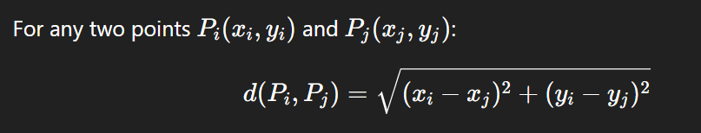

 | P1 | P2 | P3 | P4 | P5 | P6 | P7
P1 | 0.000 | 0.283 | 0.516 | 0.425 | 0.394 | 0.231 | 0.455
P2 | 0.283 | 0.000 | 0.242 | 0.180 | 0.424 | 0.132 | 0.175
P3 | 0.516 | 0.242 | 0.000 | 0.117 | 0.506 | 0.305 | 0.071
P4 | 0.425 | 0.180 | 0.117 | 0.000 | 0.392 | 0.200 | 0.104
P5 | 0.394 | 0.424 | 0.506 | 0.392 | 0.000 | 0.295 | 0.490
P6 | 0.231 | 0.132 | 0.305 | 0.200 | 0.295 | 0.000 | 0.256
P7 | 0.455 | 0.175 | 0.071 | 0.104 | 0.490 | 0.256 | 0.000

Q2. We have the following 2D data points:
Points: (2,1), (3,1), (3, 3), (4, 1), (5, 1), (6,7), (1,3), (2,5)
for K =3:
Centroid1: (2,1)
Centroid 2: (4, 1)
Centroid 3: (5, 1)

Euclidean Distance:

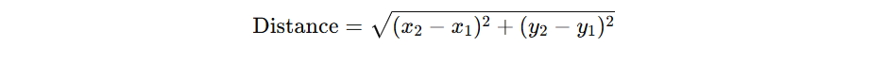

Part B — Short-Answer

Q1.
- Describe agglomerative hierarchical clustering.
Ans: • Start with each data point as its own cluster (n clusters).
• Repeatedly merge the two clusters that are closest according to a chosen linkage rule (single, complete, average, etc.).
• Continue merging until all points are in one cluster.
• Produces a dendrogram (tree) showing the sequence of merges and distances.

b) Describe divisive hierarchical clustering.
Ans: • Start with one cluster containing all points.
• Repeatedly split clusters into two parts (e.g., using k-means or some criterion) until each final cluster is singleton (or desired number reached).
• Produces a dendrogram by splitting from the top down.

c) Which one is more commonly used and why?

Ans: Agglomerative is more common because it is intuitive and easier to implement (merging requires simpler bookkeeping). Divisive methods often need a strategy to choose how to split (more complex / computationally expensive).

Q2.
- To improve clustering quality, should inter-cluster distance be maximized or minimized?

Ans: Reason: clusters should be as distinct as possible; maximizing inter-cluster distances increases separation between clusters.

b) Same question for intra-cluster distance — explain the reasoning.
- Ans: Reason: points inside each cluster should be close or similar; minimizing intra-cluster distances makes clusters compact and coherent.

Good clustering tries to maximize inter-cluster and minimize intra-cluster distances.

Q3.
- Define single link, complete link, and average link.
Ans: • Single link (MIN): distance between clusters A and B = minimum distance between any member of A and any member of B. (Sensitive to nearest pair.)
• Complete link (MAX): distance = maximum distance between any member of A and any member of B. (Looks at farthest members.)
• Average link: distance = average of distances between all pairs (each a ∈ A with each b ∈ B).

b) Explain one strength and one weakness of single-link clustering.
Ans: • Strength: can find elongated or chain-shaped clusters — it links clusters when any two points are close.
• Weakness: chaining effect — noise or single bridging points can connect clusters that should be separate, producing long thin clusters or merging clusters too early.

Q4.
- What is the role of tokenization and give one example.

Ans: Tokenization: breaking text into atomic units (tokens) such as words, punctuation, or subwords.
Example: "John's book." → tokens could be ["John", "'s", "book", "."] or ["John", "s", "book", "."] depending on tokenizer.

b) Compare stemming vs. lemmatization in terms of speed and accuracy.
Ans: • Stemming: rule-based chopping of word endings (very fast, crude). Example: "running" → "run" (sometimes "runn").
• Lemmatization: uses vocabulary & morphological analysis to return the base dictionary form (lemma), and uses POS info: "running" (verb) → "run"; "better" → "good".
Speed vs accuracy: Stemming is faster but less accurate; lemmatization is slower but more accurate (produces real words).

Q5.
- Explain what word sense ambiguity is and provide an example.

Ans: Word sense ambiguity: a single word has multiple meanings (polysemy).
Example: "I sat by the bank." → bank = river bank or financial bank. Context is needed.

b) Explain why pronoun reference ambiguity can confuse a model.

Ans: Pronoun reference ambiguity: when a pronoun could refer to more than one antecedent.
Example: "Chris met Alex. He told him the news." → Who is "he"? Chris or Alex? This confuses models that must resolve the pronoun to a specific entity.

Q6.
- Why can’t NLP tasks like POS tagging be solved by predicting each token independently?
Ans: Because POS of a word depends heavily on context (neighboring words). Predicting tokens independently ignores context and yields worse accuracy. For example, "book" in "I will book a flight" is a verb; in "I read a book" it’s a noun. Context determines the tag.
b) Give one example where decisions are mutually dependent in a sentence.
Ans: In the sentence "Visiting relatives can be annoying", the word "Visiting" could be a verb (present participle) or adjective (gerund). Deciding the tag for "visiting" affects how you tag "relatives", so tags are interdependent.

Part C — Coding
Q1.
Write Python code to perform the following steps:
- Segment into tokens
- Remove stopwords
- Apply lemmatization (not stemming)
- Keep only verbs and nouns (use POS tags)
Input text:
"John enjoys playing football while Mary loves reading books in the library."
Code:
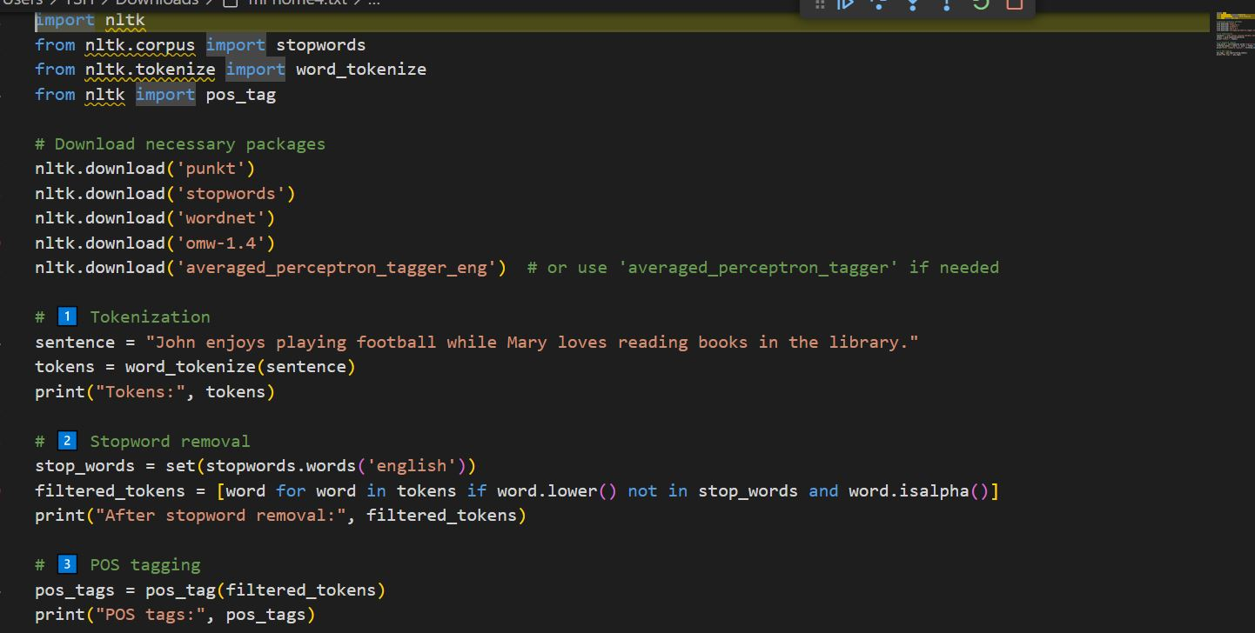
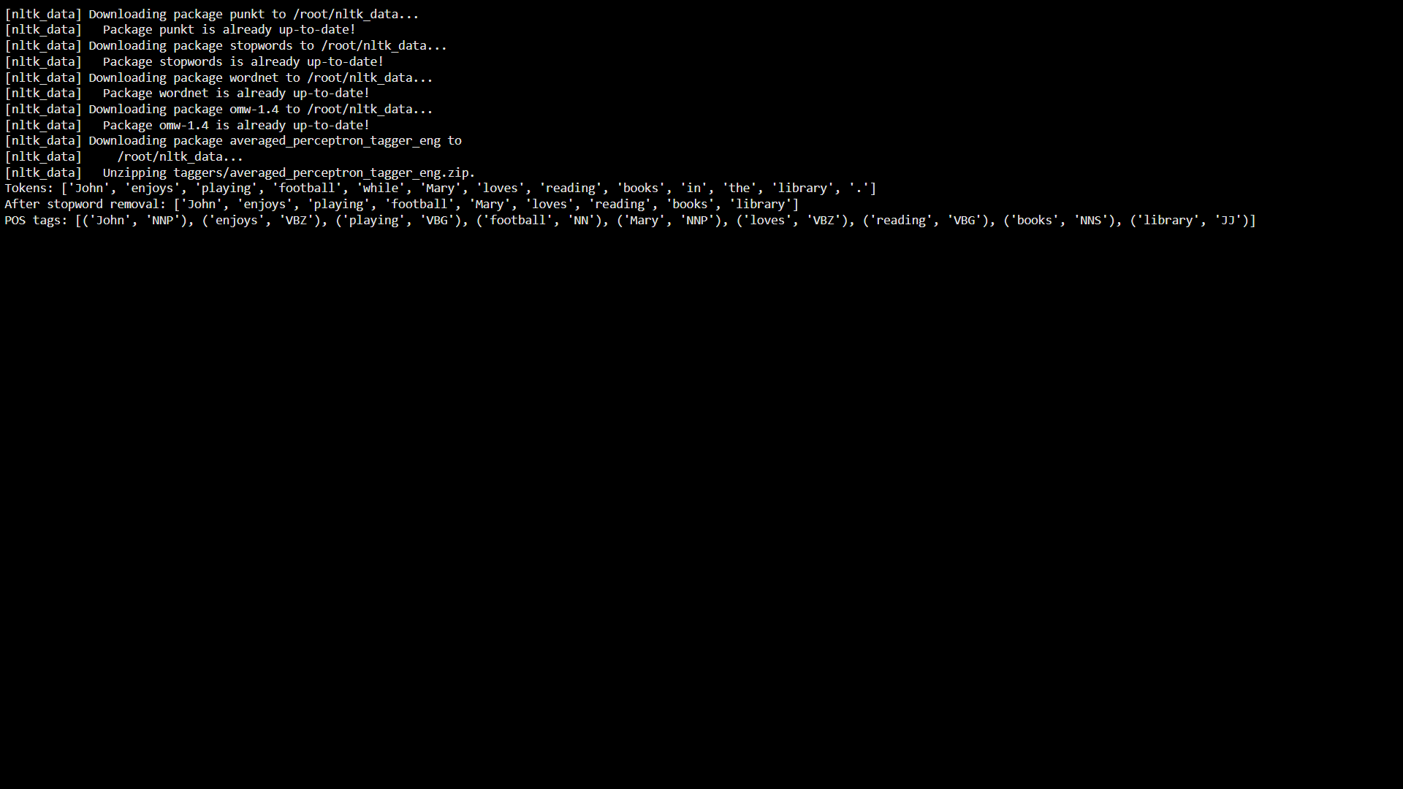

Q2.
Use Python and any NLP model to perform:
- Named Entity Recognition (NER)
- Disambiguation prompt:
If the text contains a pronoun ("he", "she", "they"), print:
"Warning: Possible pronoun ambiguity detected!"
Input text:
"Chris met Alex at Apple headquarters in California. He told him about the new iPhone launch."
Code:
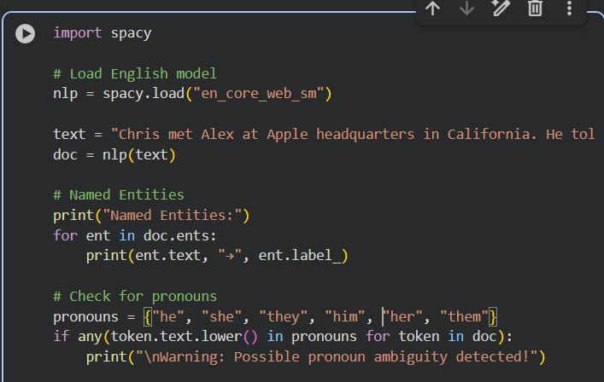
Output:
